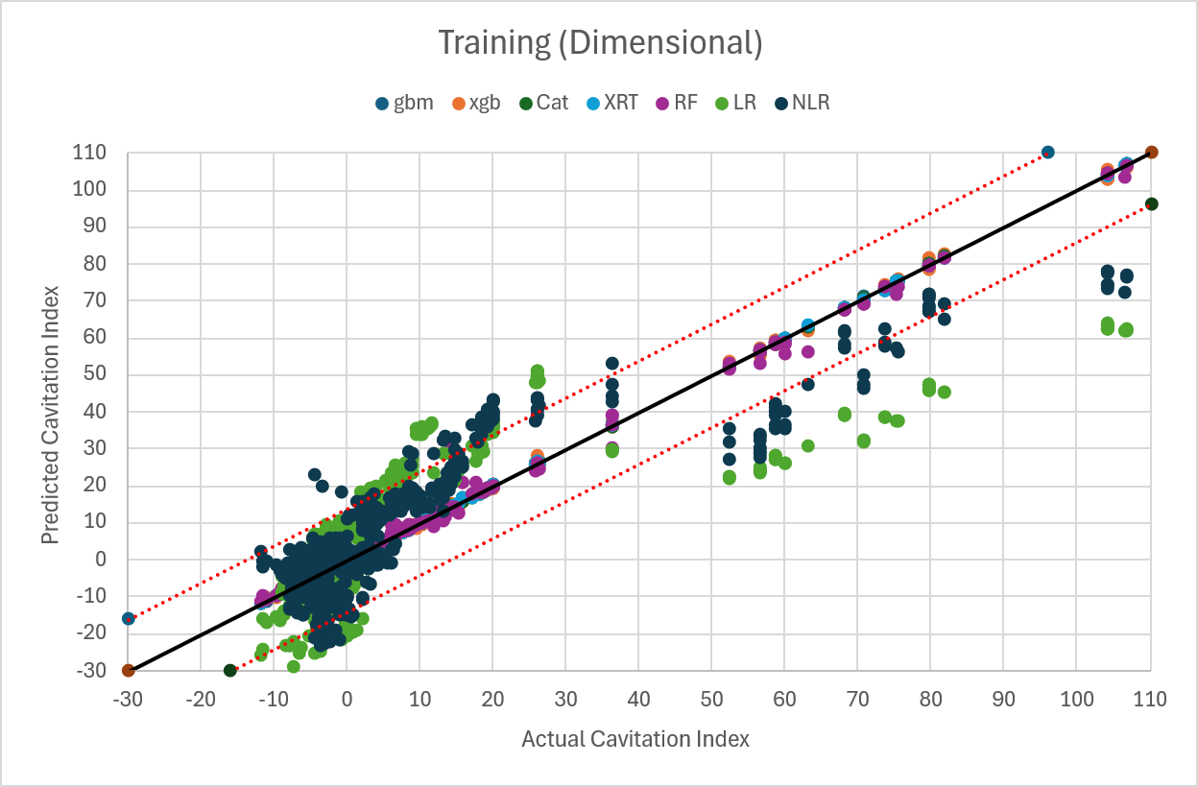
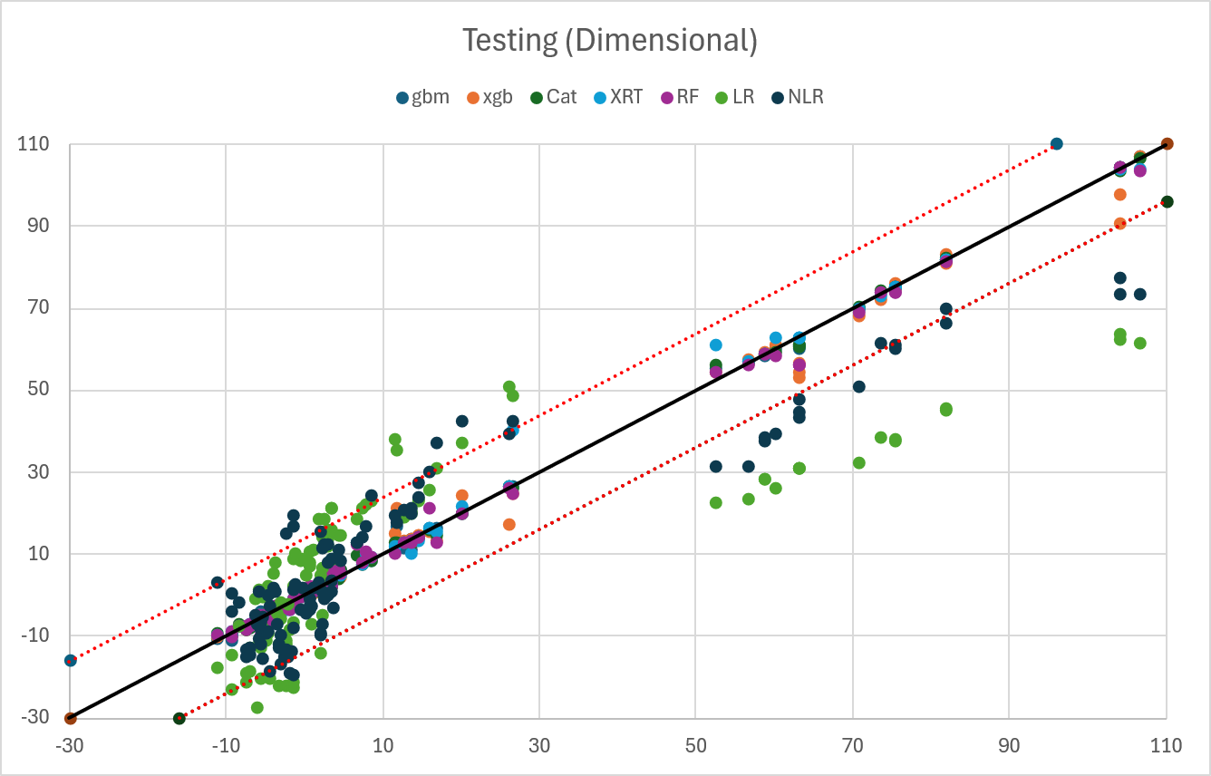

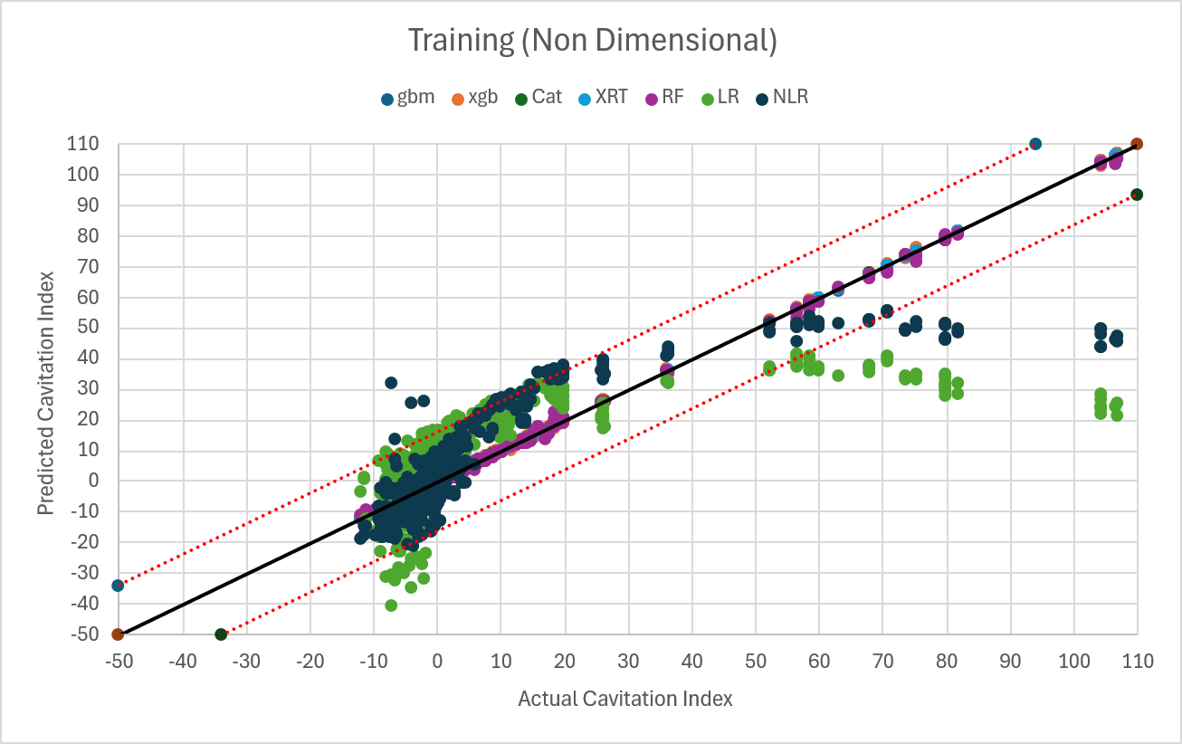
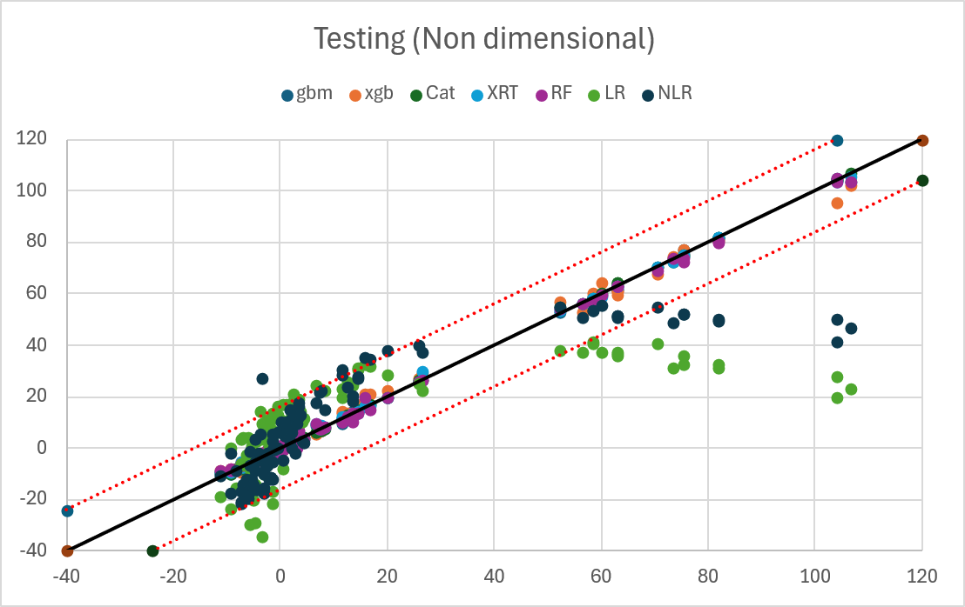

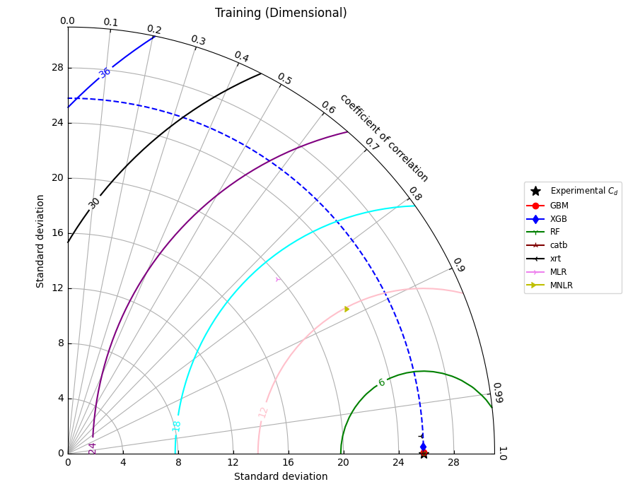

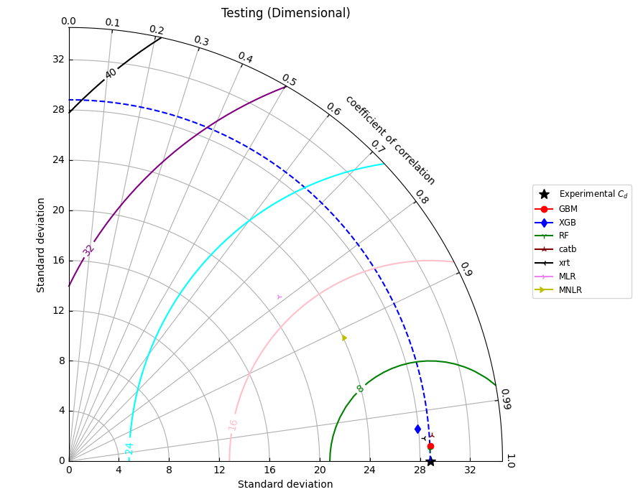

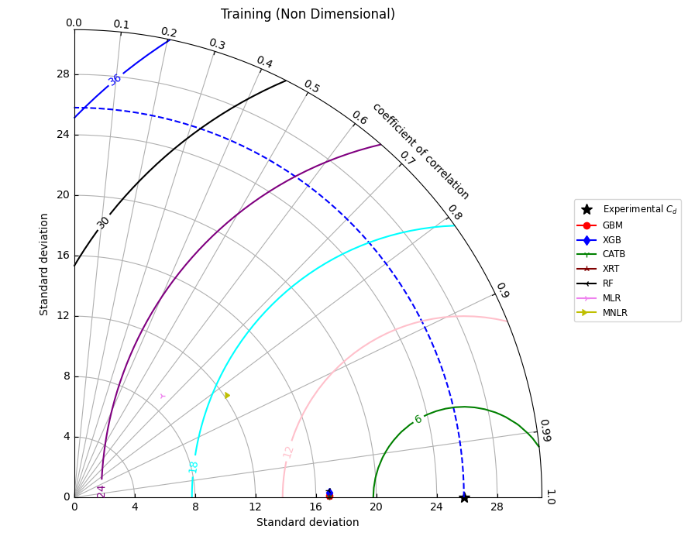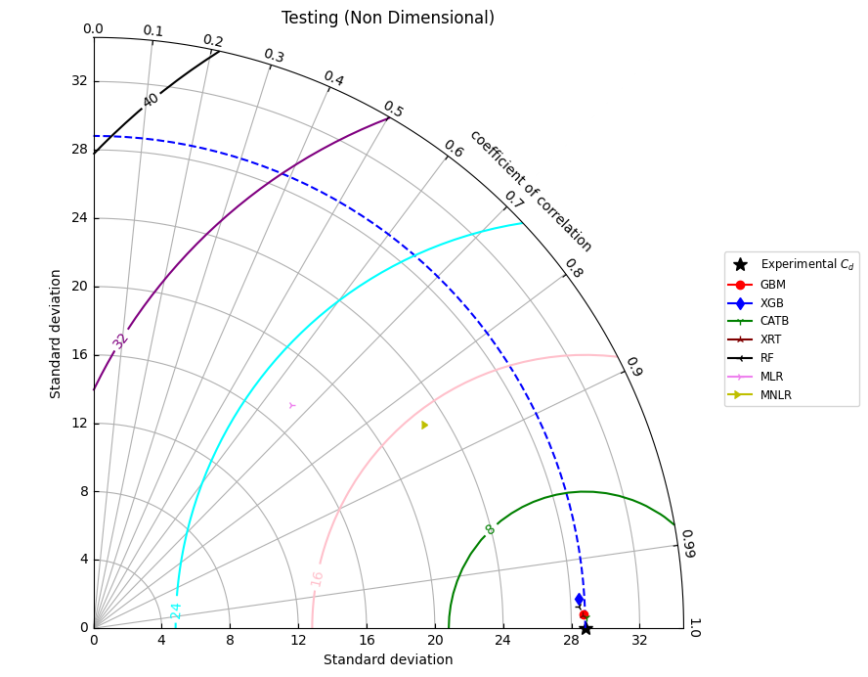

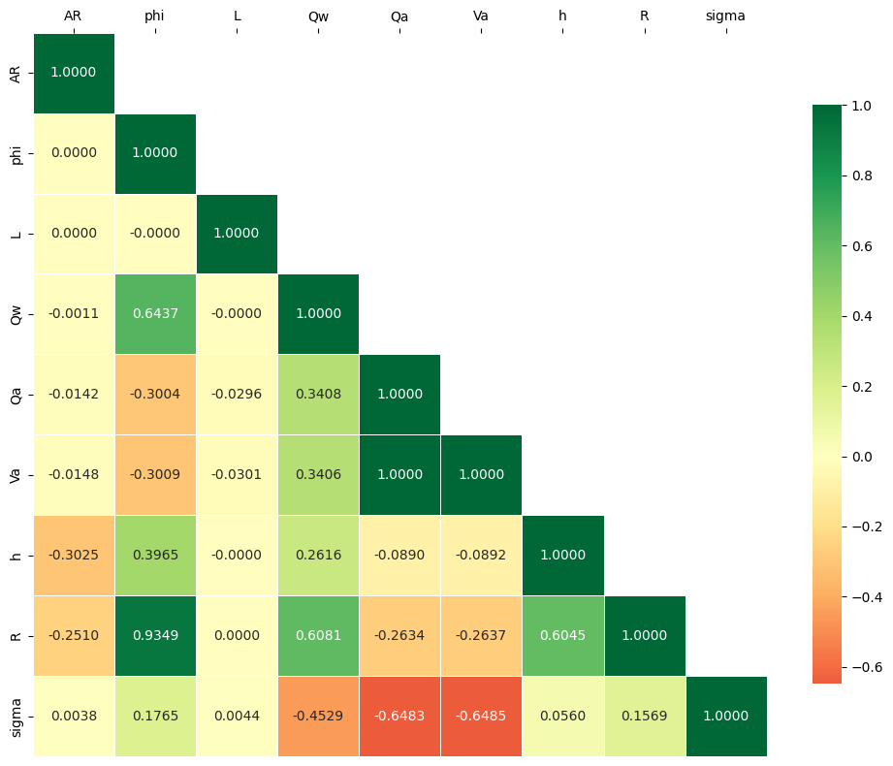

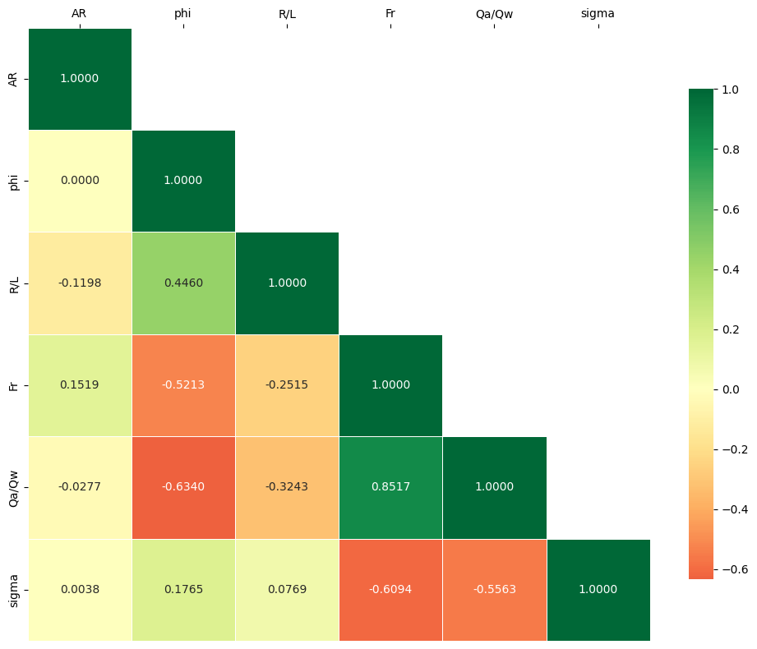

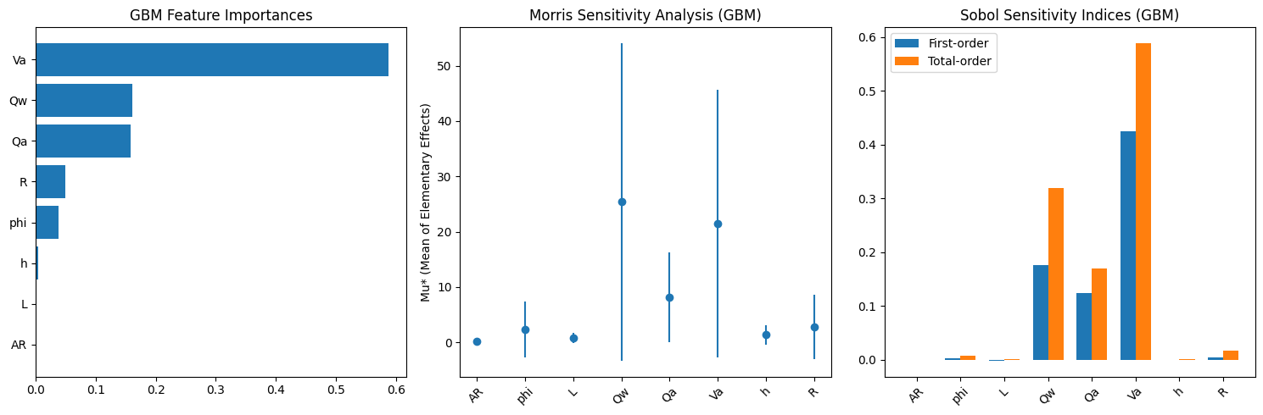
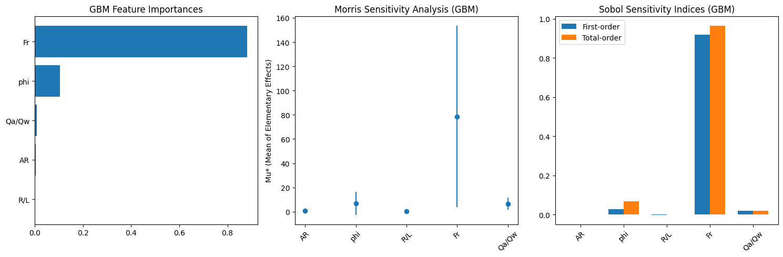
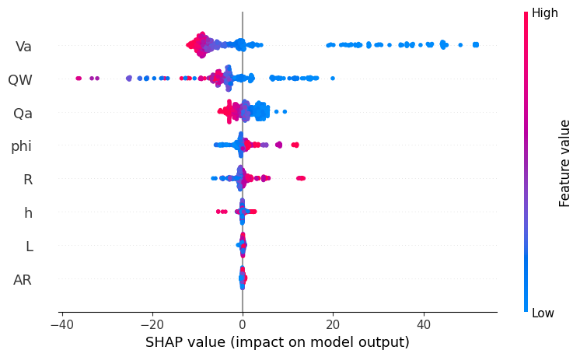

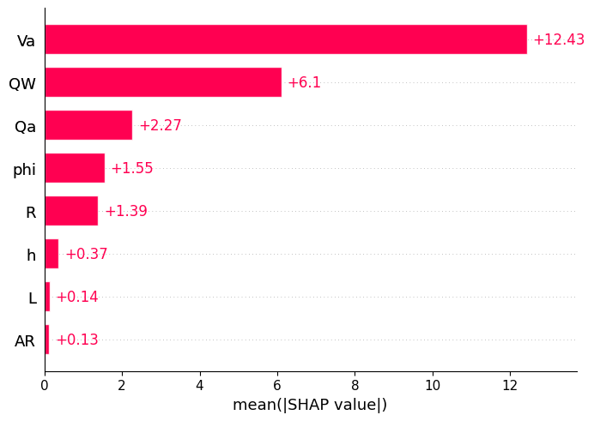

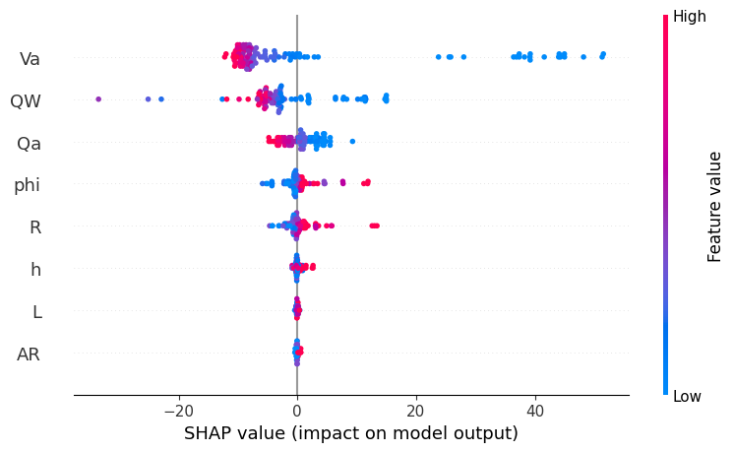

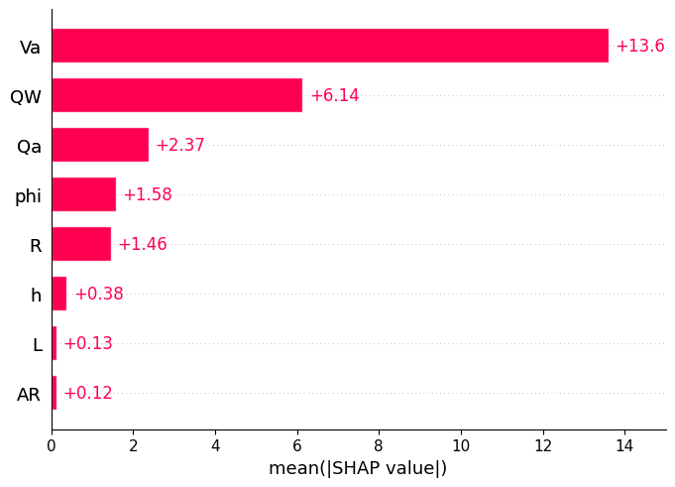

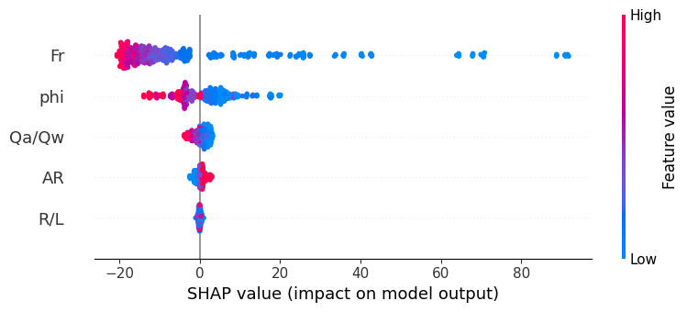

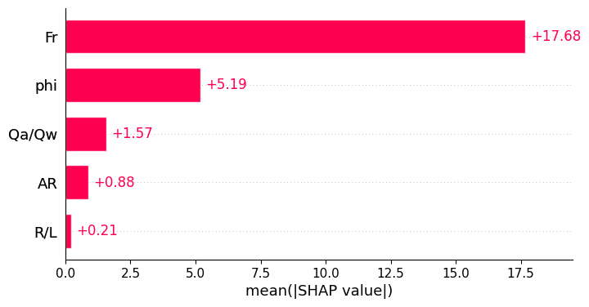

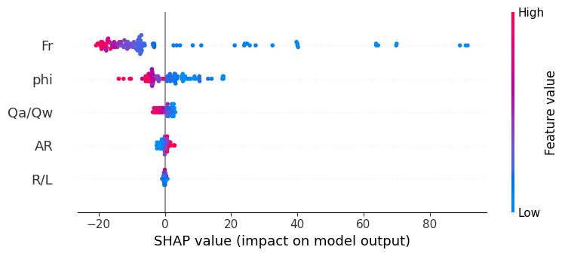

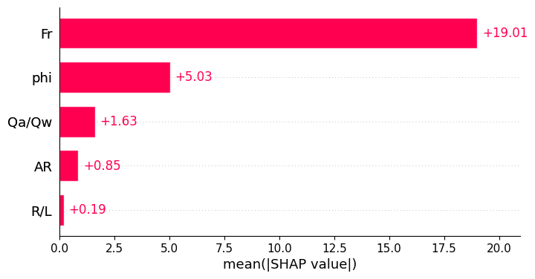

Parameters | AR | L (m) | φ (%) | $$Q_{w}\left(m^{3}/s\right)$$ | $$Q_{a}\left(m^{3}/s\right)$$ | h (m) | $V_{a}$ (m/s) | R (m) | σ
Training
Mean | 1.0953 | 28.8586 | 3.2208 | 9.1653 | 16.3706 | 10.3004 | 3.7970 | 0.0077 | 11.6272
St deviation | 0.4436 | 16.8085 | 1.9196 | 6.6370 | 14.4153 | 9.0569 | 2.6560 | 0.0031 | 25.8351
Variance | 0.1968 | 282.5247 | 3.6849 | 44.0495 | 207.8002 | 82.0279 | 7.0545 | 0.0000 | 667.4508
Kurtosis | -1.5331 | -0.7195 | -1.4110 | 0.7065 | -0.7564 | -0.7544 | -1.4660 | -0.7189 | 3.5179
Skewness | 0.2667 | 0.6986 | 0.3054 | 1.1218 | 0.5805 | 0.5816 | 0.3426 | 0.2894 | 2.0678
Range | 1.0667 | 50.0000 | 5.0000 | 28.6500 | 53.0250 | 33.3400 | 7.4486 | 0.0112 | 118.8122
Minimum | 0.6000 | 10.0000 | 1.0000 | 0.9500 | 0.0000 | 0.0000 | 0.5400 | 0.0026 | -11.9734
Maximum | 1.6667 | 60.0000 | 6.0000 | 29.6000 | 53.0250 | 33.3400 | 7.9886 | 0.0138 | 106.8388
Sum | 441.4000 | 11630.0000 | 1298.0000 | 3693.6000 | 6597.3546 | 4151.0600 | 1530.1750 | 3.1020 | 4685.7541
Count | 403.0000 | 403.0000 | 403.0000 | 403.0000 | 403.0000 | 403.0000 | 403.0000 | 403.0000 | 403.0000
Testing
Mean | 1.0634 | 30.3960 | 3.3663 | 10.2931 | 17.4100 | 10.9467 | 3.9859 | 0.0080 | 13.2283
Standard deviation | 0.4286 | 17.5454 | 1.9376 | 7.5311 | 15.4018 | 9.6840 | 2.7870 | 0.0030 | 28.9605
Variance | 0.1837 | 307.8416 | 3.7545 | 56.7175 | 237.2153 | 93.7806 | 7.7674 | 0.0000 | 838.7123
Kurtosis | -1.3408 | -0.9694 | -1.4695 | -0.1463 | -0.7790 | -0.7790 | -1.5400 | -0.9538 | 2.0752
Skewness | 0.4080 | 0.6204 | 0.1705 | 0.8306 | 0.5507 | 0.5507 | 0.3511 | 0.0867 | 1.8059
Range | 1.0667 | 50.0000 | 5.0000 | 28.5500 | 55.2039 | 34.7100 | 7.4486 | 0.0112 | 117.7732
Minimum | 0.6000 | 10.0000 | 1.0000 | 0.9500 | 0.0000 | 0.0000 | 0.5400 | 0.0026 | -11.2220
Maximum | 1.6667 | 60.0000 | 6.0000 | 29.5000 | 55.2039 | 34.7100 | 7.9886 | 0.0138 | 106.5512
Sum | 107.4000 | 3070.0000 | 340.0000 | 1039.6000 | 1758.4126 | 1105.6200 | 402.5726 | 0.8084 | 1336.0540
Count | 101.0000 | 101.0000 | 101.0000 | 101.0000 | 101.0000 | 101.0000 | 101.0000 | 101.0000 | 101.0000

Parameters | AR | φ | R/L | $$F_{r}$$ | $$Q_{a}/Q_{w}$$ | σ
Training
Mean | 1.095 | 28.859 | 0.004 | 17.985 | 1.997 | 11.627
Standard deviation | 0.444 | 16.808 | 0.003 | 12.086 | 1.840 | 25.835
Variance | 0.197 | 282.525 | 0.000 | 146.059 | 3.385 | 667.451
Kurtosis | -1.533 | -0.719 | 1.387 | 0.253 | -0.244 | 3.518
Skewness | 0.267 | 0.699 | 1.380 | 0.911 | 0.833 | 2.068
Range | 1.067 | 50.000 | 0.013 | 55.494 | 7.278 | 118.812
Minimum | 0.600 | 10.000 | 0.000 | 1.854 | 0.000 | -11.973
Maximum | 1.667 | 60.000 | 0.014 | 57.348 | 7.278 | 106.839
Sum | 441.400 | 11630.000 | 1.503 | 7247.861 | 804.910 | 4685.754
Count | 403.000 | 403.000 | 403.000 | 403.000 | 403.000 | 403.000
Testing
Mean | 1.063 | 30.396 | 0.004 | 18.041 | 1.826 | 13.228
Standard deviation | 0.429 | 17.545 | 0.003 | 12.476 | 1.778 | 28.961
Variance | 0.184 | 307.842 | 0.000 | 155.662 | 3.160 | 838.712
Kurtosis | -1.341 | -0.969 | 1.344 | 0.521 | -0.082 | 2.075
Skewness | 0.408 | 0.620 | 1.499 | 1.037 | 0.922 | 1.806
Range | 1.067 | 50.000 | 0.013 | 55.494 | 6.830 | 117.773
Minimum | 0.600 | 10.000 | 0.000 | 1.854 | 0.000 | -11.222
Maximum | 1.667 | 60.000 | 0.014 | 57.348 | 6.830 | 106.551
Sum | 107.400 | 3070.000 | 0.370 | 1822.154 | 184.453 | 1336.054
Count | 101.000 | 101.000 | 101.000 | 101.000 | 101.000 | 101.000

ML Models | Optimal Values
Dimensional
GBM | n_estimators = 310, max_depth = 7, learning_rate = 0.10664589740085356, subsample = 0.6623650248841277, min_samples_split = 17, min_samples_leaf = 2, and max_features = None
XGB | n_estimators = 474, max_depth = 9, learning_rate = 0.298, subsample = 0.962, colsample_bytree = 0.716, gamma = 0.480, reg_alpha = 0.022, and reg_lambda = 0.083.
CATB | iterations = 411, depth = 7, learning_rate = 0.11693909733978508, l2_leaf_reg = 1.0058943176207062, bagging_temperature = 0.7947457289044807, and random_strength = 0.02570983831467845
XRT | n_estimators = 147, max_depth = 12, min_samples_split = 2, min_samples_leaf = 1, and max_features = None
RF | n_estimators = 489, max_depth = 10, min_samples_split = 4, min_samples_leaf = 1, and max_features = None
Non-Dimensional
GBM | n_estimators = 252, max_depth = 8, learning_rate = 0.06285652370947764, subsample = 0.8059737929229986, min_samples_split = 9, min_samples_leaf = 5, and max_features = None
XBG | n_estimators = 374, max_depth = 4, learning_rate = 0.19506369878658875, subsample = 0.7557741773206197, colsample_bytree = 0.9008651041744119, gamma = 0.31939781060870454, reg_alpha = 1.0334200192977028, and reg_lambda = 1.5791290618713818
CATB | iterations = 441, depth = 6, learning_rate = 0.15310299327795915, l2_leaf_reg = 3.3330519675173056, bagging_temperature = 0.11689119833947537, and random_strength = 0.000706267657318276
XRT | n_estimators = 495, max_depth = 15, min_samples_split = 2, min_samples_leaf = 1, and max_features = None
RF | n_estimators = 160, max_depth = 17, min_samples_split = 3, min_samples_leaf = 1, and max_features = None

 |  | Training |  |  |  | Testing
S. No. | Model | CC | RMSE | MAE |  | CC | RMSE | MAE
1 | GBM | 1.0000 | 0.1226 | 0.0915 |  | 0.9991 | 1.2323 | 0.7536
2 | XGB | 0.9998 | 0.5099 | 0.3817 |  | 0.9958 | 2.7851 | 1.4768
3 | CATB | 1.0000 | 0.0687 | 0.0561 |  | 0.9994 | 0.9588 | 0.6639
4 | XRT | 1.0000 | 0.1267 | 0.0570 |  | 0.9974 | 2.1074 | 1.0397
5 | RF | 0.9987 | 1.2976 | 0.5372 |  | 0.9978 | 1.9500 | 1.1900
6 | MLR | 0.7680 | 16.5249 | 13.0254 |  | 0.7872 | 18.2541 | 14.5348
7 | MNLR | 0.8890 | 11.8130 | 9.5771 |  | 0.9133 | 12.1811 | 9.9445

 |  | Training |  |  |  | Testing
S. No. | Model | CC | RMSE | MAE |  | CC | RMSE | MAE
1 | GBM | 1.0000 | 0.1693 | 0.0862 |  | 0.9996 | 0.8074 | 0.5999
2 | XGB | 0.9998 | 0.4527 | 0.3473 |  | 0.9982 | 1.7544 | 1.1869
3 | CATB | 1.0000 | 0.0972 | 0.0781 |  | 0.9998 | 0.6318 | 0.4699
4 | XRT | 1.0000 | 0.0076 | 0.0042 |  | 0.9997 | 0.7625 | 0.5216
5 | RF | 0.9996 | 0.7525 | 0.4960 |  | 0.9990 | 1.3299 | 0.9974
6 | MLR | 0.6522 | 19.5603 | 14.2317 |  | 0.6623 | 21.7173 | 15.9727
7 | MNLR | 0.8352 | 14.1891 | 10.1398 |  | 0.8543 | 15.1795 | 10.7294

Combination | Parameter Removed | Train CC | Train RMSE | Test CC | Test RMSE
$σ=f\left(AR,L,ϕ,Q_{w}​,Q_{a}​,h,V_{a}​,R\right)$ | — | 0.99999 | 0.012752 | 0.998924 | 1.824752
$σ=f\left(L,ϕ,Q_{w}​,Q_{a}​,h,V_{a}​,R\right)$ | $$AR$$ | 0.999994 | 0.007439 | 0.998968 | 1.715453
$σ=f\left(AR,ϕ,Q_{w}​,Q_{a}​,h,V_{a}​,R\right)$ | $$L$$ | 0.999977 | 0.03032 | 0.998601 | 2.369494
$σ=f\left(AR,L,Q_{w}​,Q_{a}​,h,V_{a}​,R\right)$ | $$ϕ$$ | 0.99999 | 0.013369 | 0.998964 | 1.739323
$σ=f\left(AR,L,ϕ,Q_{a}​,h,V_{a}​,R\right)$ | $$Q_{w}​$$ | 0.938227 | 79.758257 | 0.8757 | 200.617672
$σ=f\left(AR,L,ϕ,Q_{w}​,h,V_{a}​,R\right)$ | $$Q_{a}​$$ | 0.999993 | 0.008764 | 0.999004 | 1.680662
$σ=f\left(AR,L,ϕ,Q_{w},Q_{a}​,V_{a}​,R\right)$ | $$h$$ | 0.999991 | 0.011828 | 0.998908 | 1.830652
$σ=f\left(AR,L,ϕ,Q_{w},Q_{a}​,h,R\right)$ | $$V_{a}$$ | 0.999987 | 0.016676 | 0.999069 | 1.553297
$σ=f\left(AR,L,ϕ,Q_{w}​,Q_{a}​,h,V_{a}​\right)$ | $$R$$ | 0.999988 | 0.016251 | 0.99897 | 1.720705

Combination | Parameter Removed | Train CC | Train RMSE | Test CC | Test RMSE
$σ=f\left(AR,ϕ,R/L,F_{r},Q_{a}​/Q_{w}​\right)$ | — | 1.000 | 0.010 | 1.000 | 0.482
$σ=f\left(ϕ,R/L,F_{r},Q_{a}​/Q_{w}​\right)$ | $$AR$$ | 1.000 | 0.030 | 0.999 | 1.289
$σ=f\left(AR,R/L,F_{r},Q_{a}​/Q_{w}​\right)$ | $$ϕ$$ | 1.000 | 0.405 | 0.984 | 26.662
$σ=f\left(AR,ϕ,F_{r},Q_{a}​/Q_{w}​\right)$ | $$R/L$$ | 1.000 | 0.016 | 1.000 | 0.447
$σ=f\left(AR,ϕ,R/L,Q_{a}​/Q_{w}​\right)$ | $$F_{r}$$ | 0.940 | 77.972 | 0.830 | 277.919
$σ=f(AR,ϕ,R/L,F_{r})$ | $$Q_{a}​/Q_{w}​$$ | 1.000 | 0.040 | 0.999 | 1.332

